**Our Energy Future – Week 1**

**Introduction to Energy Part 1**

The definition of *energy* is the capacity to do work. In turn, the definition of *work* is . There are many different kinds of energy, the most common being:

* Chemical
* Solar
* Mechanical
* Nuclear
* Electrical

We interact with many of these different kinds of energy every single day, however the first thing we need to understand when studying energy is the *first law of thermodynamics:*

*Energy can neither be created nor destroyed, it can only be transformed from state to another*

What this means is that we cannot *produce* energy, we can mine and wrangle energy and convert it into power needed to live our lives.

The primary sources of energy are broken down below. As you can see, over 80% of all energy come from fossil fuels

* Oil: 33.2%
* Coal: 27%
* Gas: 21.1%
* Combustibles: 10%
* Nuclear: 5.8%
* Hydro: 2.2%
* Other: 0.7%

The mining, processing and burning of these fossil fuels has significant consequences in a wide array of aspects that are foundational to society – the environment, the economy, and how people get sustenance through food and water.

Another important concept is the relationship between energy and power. Energy is everything that could potentially be used for power or electricity, which refers to what is available for immediate use.

Due to the fact that energy is lost during the processes of mining, transmitting, storing and usage, the amount of energy required is always more than the amount of power available.

*Why is energy so important?*

Obviously in anything and everything that we do on a daily basis, we use energy. Taking into account food and fuel, 70% of the all commerce on the planet ($5.8 trillion in 2016) relates to the usage of energy, and is growing very fast with the expected market to grow 40% by 2020. Most of this growth is located in developing countries – China and India, for example.

In addition to the sheer size of the market, quality of life is positively correlated with the usage of energy. The below screenshot illustrates this point.

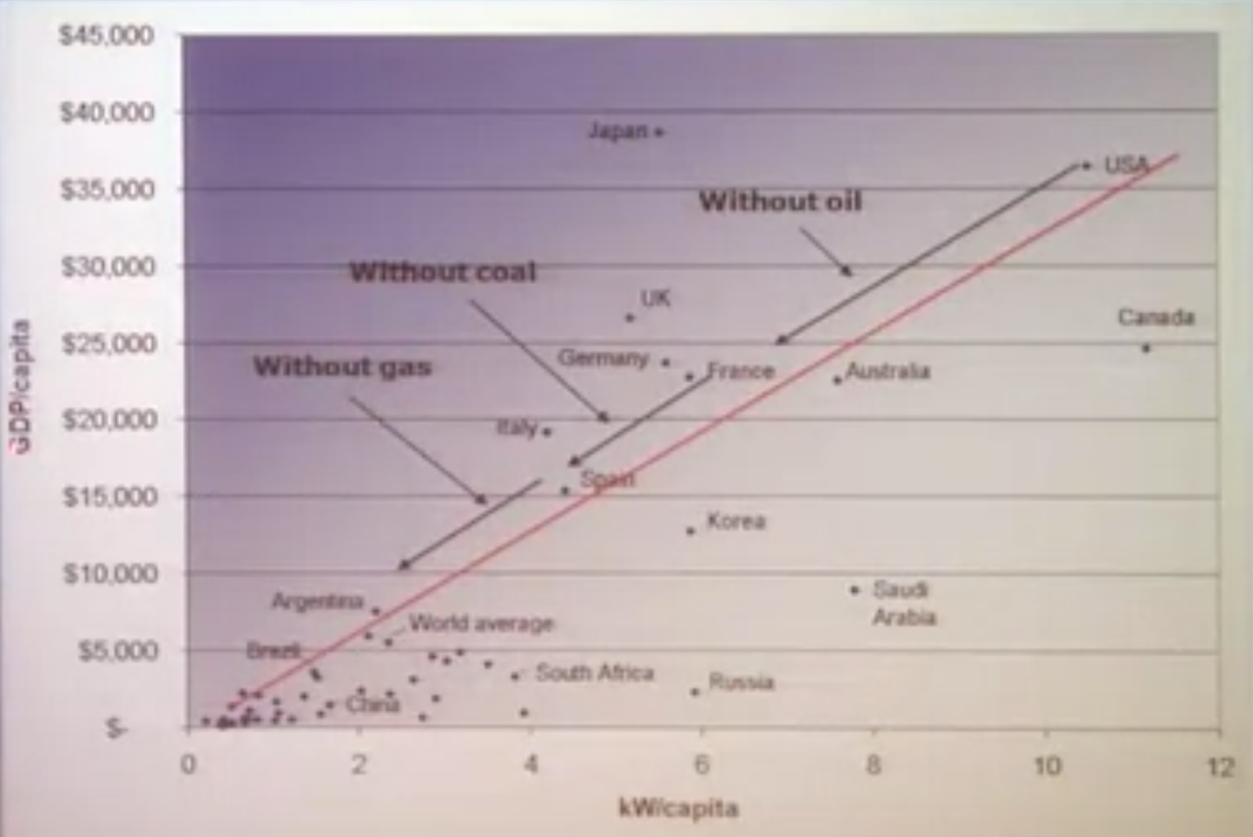

All things being equal, if you want to increase your Gross Domestic Product, you can do that by increasing your energy consumption. Also notice how low on the graph that China and India are. Both countries are continuing up the slope of this graph, however and combined these two countries have 1/3rd of the world’s population. This is the main reason why the market for energy is expected to grow by 40% by 2020.

*Why do we use liquid fuels?*

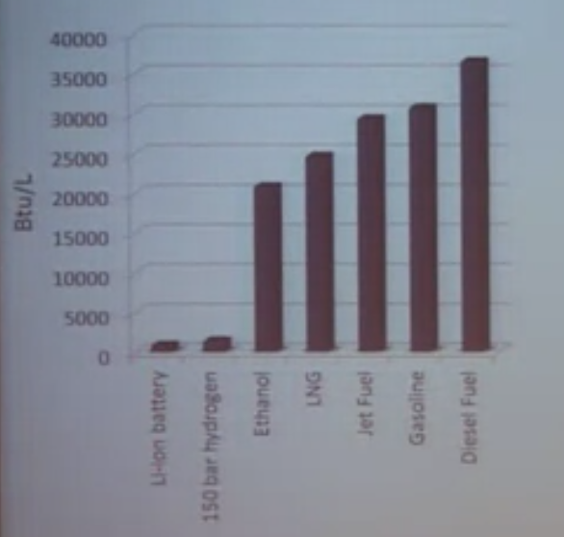The reason we use liquid fuels is because they are in actuality wonderful things and are fantastic stores of energy while remaining incredibly inexpensive.

While electric cars have their advantages, they run on lithium ion batteries which store a very small amount of energy in comparison to liquid fuels like gasoline and diesel.

They are also cheap in the grand scheme of things. A gallon of gasoline is roughly $0.60 per pound, cheaper than potatoes or rice or anything you can get on the planet besides dirt.

These are the reasons why fossil fuels are in use and will continue to be used into the future.

The below graph shows the distribution of oil consumption by region, and underscores the point that the growth in energy consumption is driven mostly by China and India.

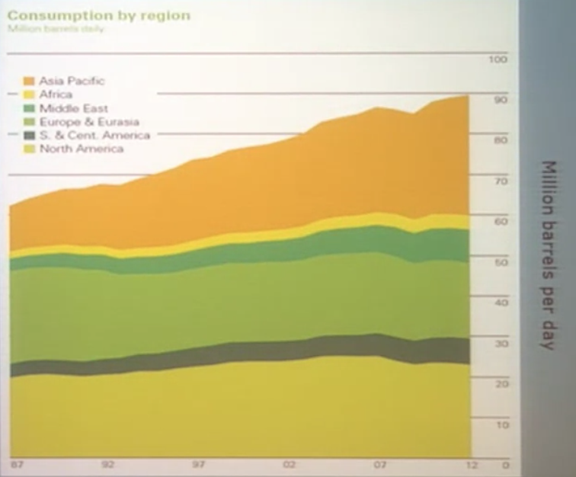The increase in the Asia Pacific is also driven by electrification in areas that were previously not, and so more people are using energy in those locations; there are still areas in these regions that are yet-to-be electrified and so the amount of oil consumption in these regions will continue to increase. Additionally, as these areas become more affluent, some of the creature comforts that are ubiquitous in the US and Europe will continue to propogate in the developing regions. In China, for example, 19 million new cars are being put on the road every year. That number is similar to the US, but in the US these 19 million new cars are replacing old ones.

Notice that the usage of petroleum Europe and the US has declined in recent years, mainly due to an increase in efficiency in our automobiles and our housing. This increase in efficiency was partially spurred on by the CAFE (Corporate Average Fuel Economy) standards first enacted in the 1970s.

**Introduction to Energy Part 2**

As oil is a non-renewable energy resource, it inevitably leads to the question of when will (or did) we reach peak oil production. In 1956, a guy name M. King Hoover predicted that humanity would reach peak oil production sometime around 1970 and be at around 10 million barrels per day.

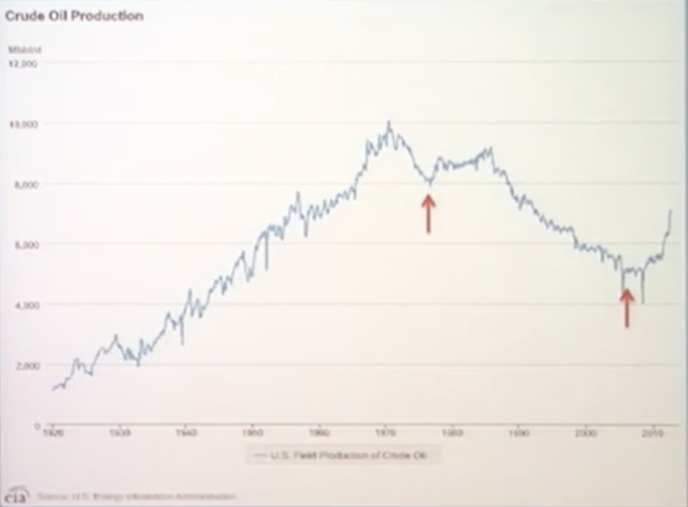That turned out to be more or less true, due in large part to two important events:

* 1970s: Arab oil embargo which spiked the price of oil, which forced the US to look for other sources of oil like the north shore of Alaska
* 2007 – The price of oil briefly spiked to $150/barrel and has remained nearly continuously above $100/barrel, making fracking economical

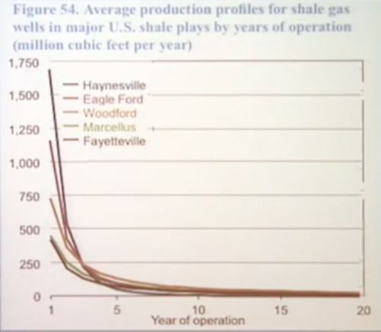*Fracking and energy independence*

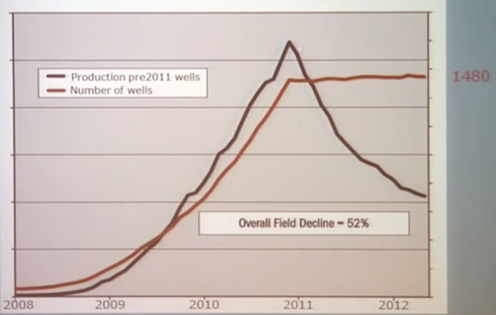Since the price increase of oil in 2007, fracking – a 50-year old technology – has taken off. The reason why it all of a sudden has appeared on the scene is because the wells which mine shale gas from the process of fracking are only productive for roughly three years after their inception. Oil prices need to be high to warrant an investment which will not produce returns after three years. The graph to the right illustrates this concept by looking at the production of major shale gas wells over the number of years each has been in production.

The graph to the right shows the same concept a different way. The person who did the analysis noted that the reason why fracking production has increased so much is because there are an exponential number of wells that are being put into production. When he held the number of wells constant after 2011, the production of those same well fell dramatically.

Contrast that with a traditional oil well, which remains productive for 20 years.

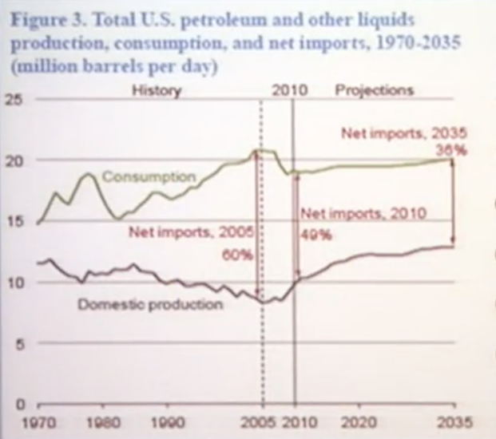However, due to the uptick in the number of fracking wells, there has been some predictions that the US will become a net exporter of oil sometime soon in the future. The issue with this is that there is a huge gap between consumption and production of petroleum and liquid fuels now and into the foreseeable future; the Department of Energy forecasts 36% more consumption than production in 2035.

The good news is that the efficiency of that energy being consumed is increasing dramatically, and is expected to continue to do so in that same time frame.

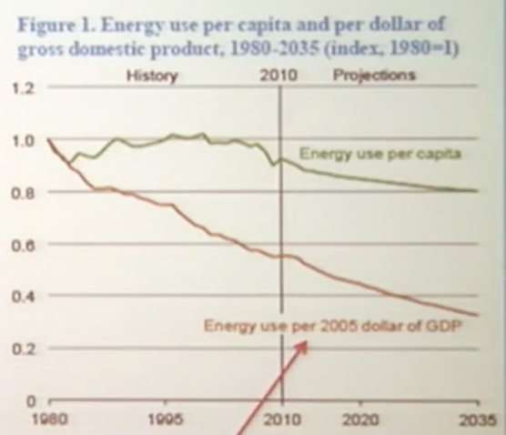

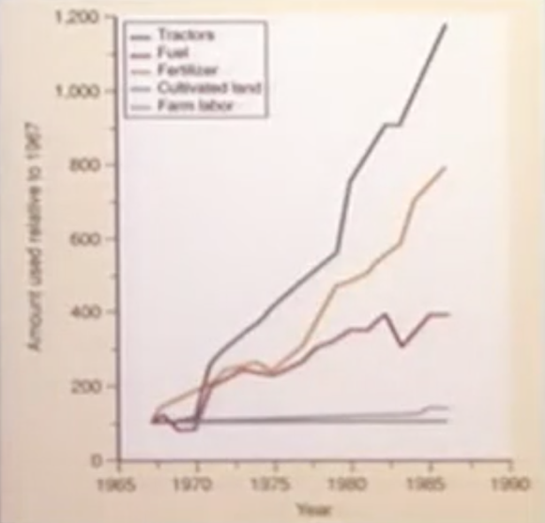

*Food and Fuel*

A large problem in the 21st century is going to be how society feeds its population. The Green Revolution that began in the 1960s occurred not because we had more farmers or more farmland, but rather we put more tractors and more fertilizer we put into the process of agriculture. In other words, we put more energy into the process. We could do that because oil was so cheap at that time, into the future we cannot expect the price of oil to be low enough to provide food cheap enough to feed a large portion of the world’s population.

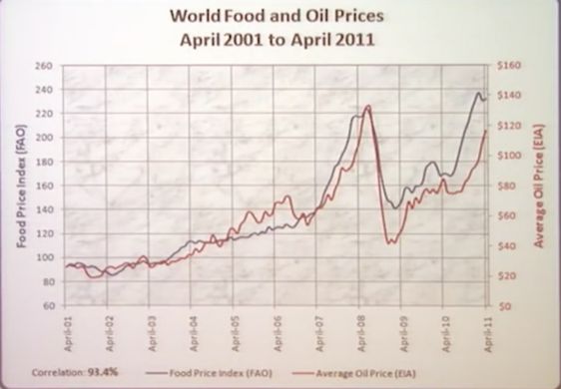

To underscore this point, the graph to the left shows the price of food and the price of oil on top of one another, with high levels of correlation between the two.

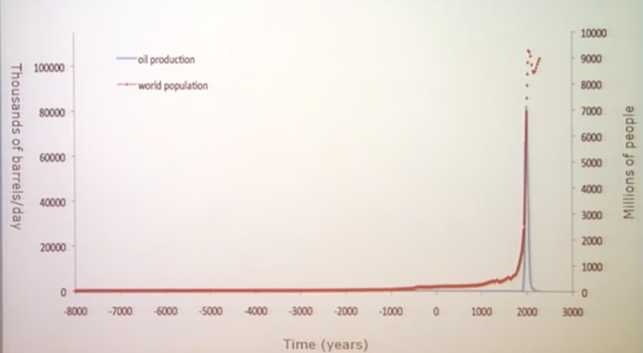Similarly, the amount of oil production tracks in line with the world’s population. The problem we are facing is how to produce food for the world’s poorest segments when we cannot put cheap oil into the process.

The good news is that the sun provides 86,000 terawatts of energy every year. The world consumes 16 terawatts energy every year (85% from fossil fuels). This total consumption is a drop in the bucket (1/6000th) compared to the energy provided by the sun, and we need to figure out a way to harness the energy from the sun at an efficient enough rate to power the world’s energy needs.